AVF1403_HOMEWORK 2014/03/17

Weather App :
My weather app is an app that will get the weather for a given location. Everyone will be able to use it. Wherever the user is in the world using their geolocation coords on their tablet. The core functionality will focus on using simple design elements while giving the user what they want to know quickly. They will be able to look at weather in their saved locations.
Similar APPS**:
Solar : Weather (by Hollr Inc)
Stars :
4.5 Stars (188 reviews)
ScreenShots :
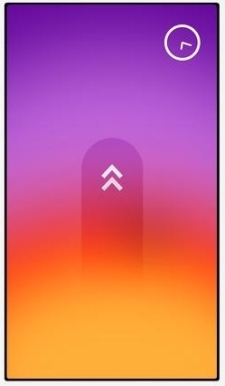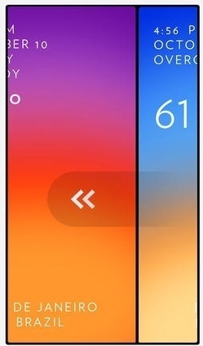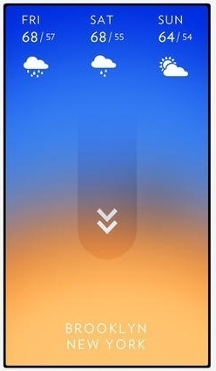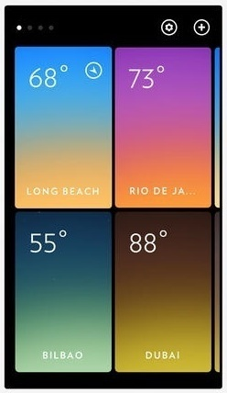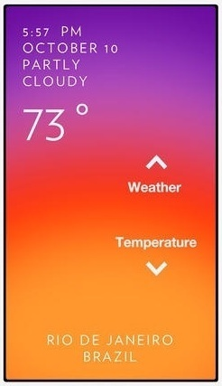
Reviews :
Navinfl -
GOOD :
- This app is simply gorgeous! The interface that is so simple to use -- uncluttered and and to the point. While it doesn't give you wind speed and other data it does let you see the temperature and weather conditions literally on a minute by minute basis simply by swiping your finger up and down the screen. I use it every morning before planning my day.
IMPROVEMENT :
- My only suggestion would be for the developer to somehow have the fonts change to a lighter or darker color depending on the background. While not a big deal, sometimes the white font can be difficult to see with a very light background. Otherwise, this is a great app!

I left wp8 -
GOOD :
- I really like the size of the app below 3 MB and has a nice design. Show the basic and min by min temperature. Swiping down shows a 3 day forecast. Swiping up shows the temperature and conditions throughout the day. Swiping from right to left will allow you add / view locations.
IMPROVEMENT :
- Although swiping from right to left does nothing. I think the developer could add current wind speed. What the temperature currently feels like and the humidity (maybe the dev can add an add in that tab too, it wouldn't be intrusive).

Haze (by Robocat)
Stars :
4.5 Stars (9748 reviews)
ScreenShots :
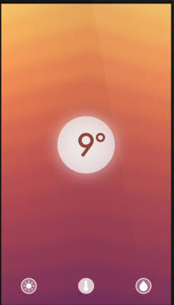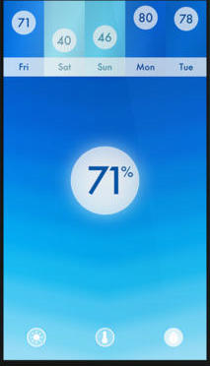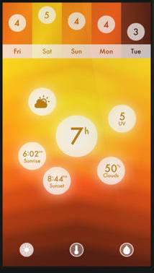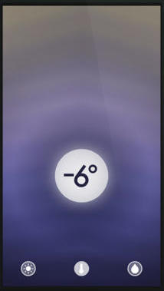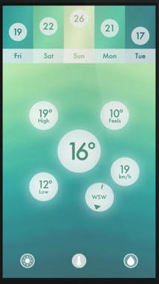
Reviews :
Loving person123-
GOOD :
- I love the simplicity of the design and the reporting of the results from a user interface perspective. Simple and to the point.
IMPROVEMENT :
- Few things to add:
  - More drill-down capability, like touching a day’s feature (e.g. temp) and you drill-down into hourly temps, or verbal summary of weather conditions
  - Ability to set location
  - Ability to store locations
  - Ability to refresh data manually
  - Explanation or further drill-down on the “sub” bubbles
  - If main bubble is “exploded’ e.g. with ‘sub bubbles showing retain the “level” of detail when switching/tilting to another view

lbss2016 -
GOOD :
- This app is one of the most cohesive and fluent apps I have ever seen. It flows together like nothing else. I also like the elegant design of the app as well as the changing background and foregrounds. The are, however, a couple of complaints that I have about it.
IMPROVEMENT :
- First off, there should be functionality with the iPad like most other apps have. Secondly, there should be no charge for the iPad app, don't do what PvZ and Angry Birds did and charge for an iPad version. Finally, I would like there to be a radar map. Don't just do what Weather Channel did and include a basic map with the radar. You should go about and beyond the competition and make your own version of the map in the style of your app.
- I really do like your app, and as a student that walks to and from school every day, it helps me infinitely. Thanks for listening to my opinion.

Weather Line - Accurate Forecast, Temperature Trend, and Monthly Average (by Roboca)
Stars :
4.5 Stars (246 reviews)
ScreenShots :
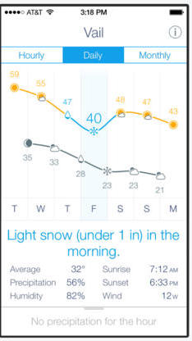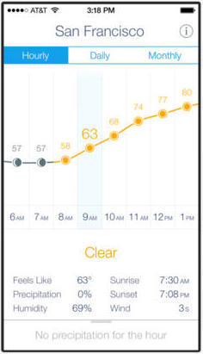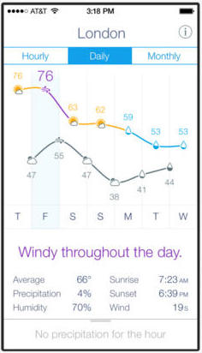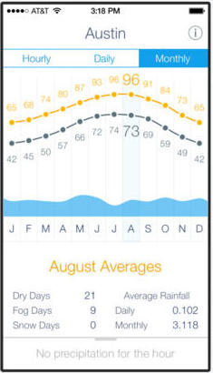
Reviews :
canyonblue737 -
GOOD :
- I am a weather junkie as an airline pilot. While I do use "high end" weather apps for aviation specific information I like to use a general and more beautiful program for everyday weather review.
- The line chart format is brilliant. It by far is the best app on the market for showing at a glance and hour by hour what the weather will actually be. No fancy swipes or tiny graphics just elegant and right in your face.
IMPROVEMENT :
- Too bad the app misses one basic ingredient which in my opinion is still essential to a primary weather app. RADAR. Where is radar? Seeing the local area Doppler is still critical to view potentially serious weather heading to your location and should be integrated. So, so close.

tomshafer -
GOOD :
- The day's weather, the week's weather, and the monthly averages for the year are presented in smart line graphs. The app's creators have put together the best layout I've seen: the weather can be read with the ease and understanding of an analogue clock.
- Some reviews have complained that the weather data presented are inaccurate, and I've not experienced this at all. I have five other weather apps (call it a fetish), and the forecast and current weather info on Weather Line have never disagreed with the data presented by these other programs

Mizzle: The Weather App (by Luca Silverentand)
Stars :
4 Stars (7 reviews)
ScreenShots :
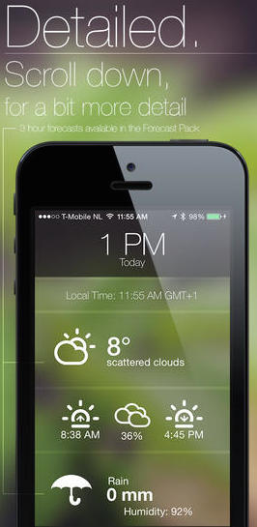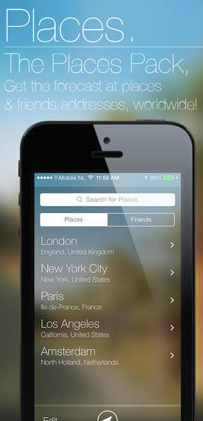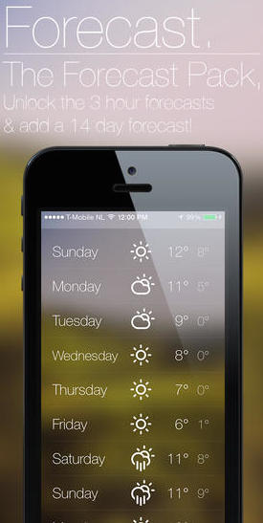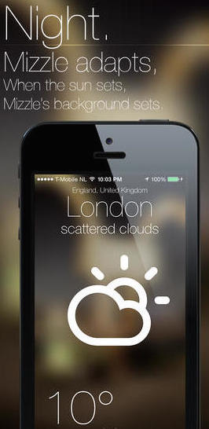
Reviews :
aphexdrukqshxc -
GOOD :
- I was really trying to find a weather app without a million different things on it because I'm not a meteorologist. Gives simple weather and a forecast (if you pay 99 cents) and looks absolutely beautiful doing it.
IMPROVEMENT :
- Needs push notifications.

BobYourUncle -
GOOD :
- Great looking "flat” app.
IMPROVEMENT :
- Not enough Information on screen.
- Takes to much effort to get data.
- Does not work properly.

Yahoo Weather (by Yahoo)
Stars :
4.5 Stars (28862 reviews)
ScreenShots :
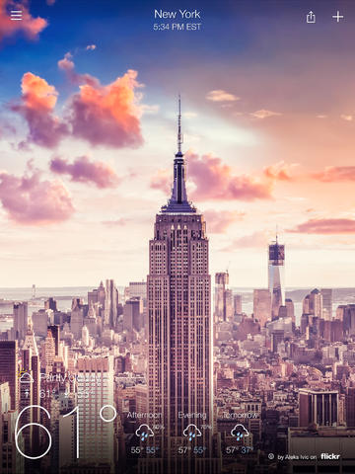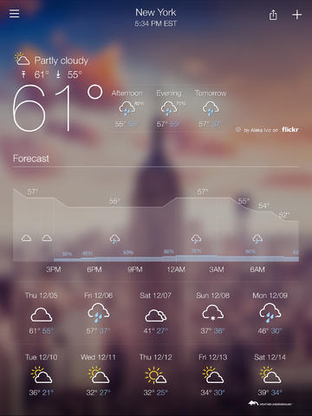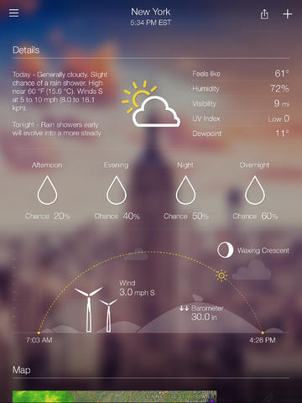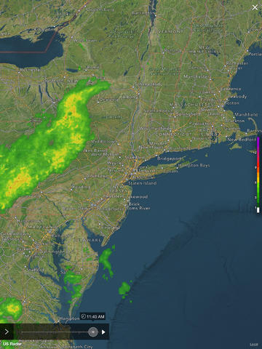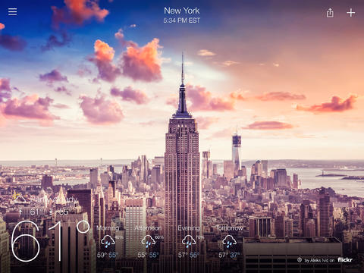
Reviews :
ThinkFlight -
GOOD :
- The flow and design is very well done in my opinion. Looks good, easy and quick to see the relative info I need just by scrolling, I don't need to go into other menus or poke other buttons to get the whole weather picture.
- Runs smooth on my ipad mini /w retina and iPhone 5.
- Has the ability to share the screen I, looking at via SMS and other common share features.
IMPROVEMENT :
- All severe weather alerts are turned on for the cities I have added to the list to watch, but I am not getting ANY alerts or push notifications. This needs to be fixed ASAP.
- Missing the above alerts Within the app as we'll, they appear NOT to show up at all

David using iphone 3G -
GOOD :
- This is a beautifully designed weather app! It has a clean modern look, and all the information you want is presented as you simply wipe down... I like the detailed forecast, and how you can swipe the hourly forecast to see the next 24 hours. The sun animation for time of day at the bottom of the screen space is a nice touch. It is an elegant user interface- Apple's weather app should be this good.
IMPROVEMENT :
- Maybe it is a transient bug, but the screen background photos are disconcerting because they don't reflect the time of day or current weather conditions (blue sunny sky with fluffy clouds when it is grey and snowing, or even daylight skies at night. They seem random, and sometimes not even accurate for the location.
- I have severe weather alerts enabled for my location, along with allowing privacy and location settings. We have a winter storm warning here today no push notification came up. Though weather alerts show up when opening the app.
- The radar map seems inaccurate, and has no key for the colors. We have a snow storm but the map is showing green clouds.

The Weather Channel for iPad (by The Weather Channel Interactive)
Stars :
4 Stars (1350 reviews)
ScreenShots :
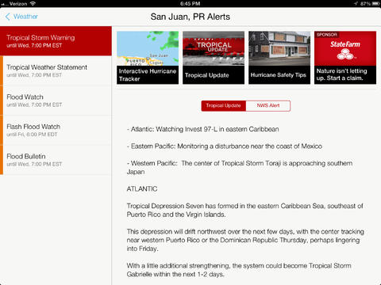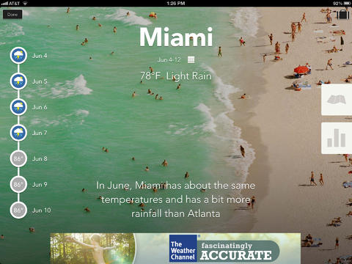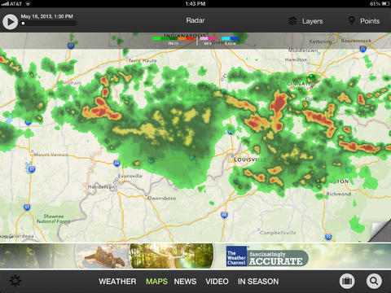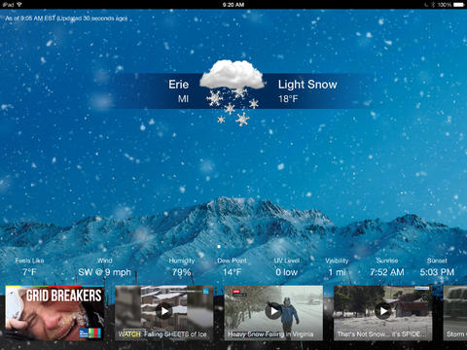
Reviews :
A2gretta -
GOOD :
- I like the layout and usefulness of this app.
IMPROVEMENT :
- Hated the active advertising that runs along the bottom. The ads do everything possible to be annoying, using flashing lights, for example--and they are irrelevant for me.

GADave -
GOOD :
- -------------------
IMPROVEMENT :
- Besides now having much worse predictions (can't even predict a day ahead), in the prior version you could have a list of favorite cities to view their weather, and if you just wanted a one-off check of a city not on the list, fine, but it didn't change your list unless you eliminated a city and substituted the new one.
- Eliminated my city of Peachtree Corners, GA (largest city in a Metro Atlanta county). The other apps have my city, but The Weather Channel (that is based in Atlanta) deleted it! Generally, the new version is worse than the old one.

Today Weather (by savvy apps, llc)
Stars :
4 Stars (27 reviews)
ScreenShots :
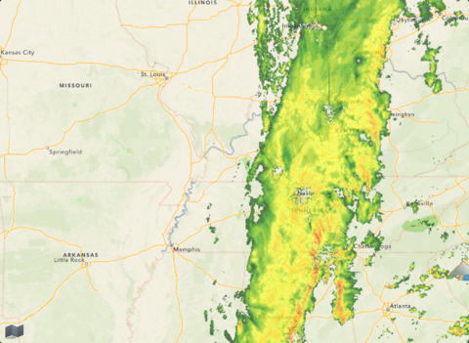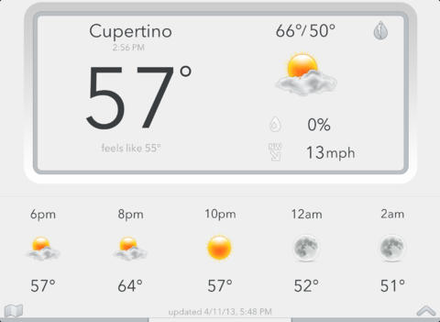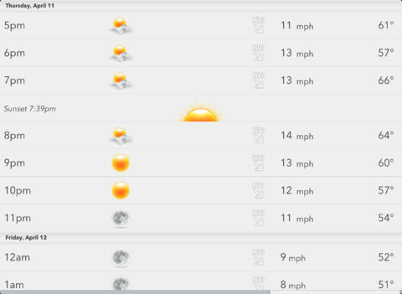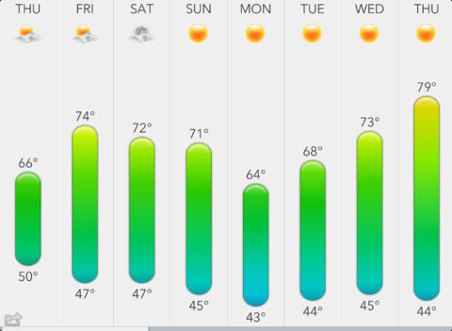
Reviews :
Scurzuzu -
GOOD :
- I don't need to see satellite imagery or crazy meteorological details. I just want the current temperature and some best guesses for the rest of the day, and then the week. So this is perfect for my needs.
- It's also fast and easy to use, so I spend a minimum amount of time checking the weather, yay.
IMPROVEMENT :
- ------

GADave -
GOOD :
- Extremely minimalistic presentation of the weather with a beautiful design.
IMPROVEMENT :
- needs animated weather maps
- show current humidity %.

** App Information, Pictures, and User Reviews found on itunes.apple.com

Conclusion:
Based on the similar apps above, I know now that I have to create a simple app, but not too simple. What I notice is that if there is a moving/transitioning background the text needs to contrast the background so the user can see what the temperature is. Also there needs to be some standard labels (such as location, temperature (both F and C, as well as high and low), (possibly also sunrise and sunset), forecast for day, and 7-day forecast, last updated), as well as swipe gestures. Also the design is very, very important, need to focus on the important information and logic rather than all the fancy esthetics.

http://api.wunderground.com/api/4e7dc583deb76743/forecast7day/conditions/astronomy/hourly/geolookup/q/37.776289,-122.395234.json

AVF1403_USER SENERIO FEILD TEST 2

A friend and you plan to go on a last minute vacation in Winter Park for a few days and want to know what the weather is like for the week. You have downloaded 32 Bit Weather on your iPad to accomplish this.
              - Launch 32BIt Weather.
              - Look at the current weather plus the 7 day forecast.
              - Make a list out loud some items what you would bring on your vacation based on the weather provided.
              - Refresh the window to make sure the weather is up to date.
              - Save the location to the Cloud.
              - Exit the App

User Test 1:
- iPad Experience : Medium
- Problems: data did not appear right away when network was turned on. Needed to be refreshed and then clicked again.
- Comments : User completed all tasks with only a few issues. Namely the getting the data to appear on the widow.

User Test 2:
- iPad Experience : High
- Problems: User was confused when update did not update to current time.
- Comments : Only one problem was that the user was confused with the alert said that data was updated, but last update label did not change

User Test 3:
- iPad Experience : High
- Problems: User was confused when update did not update to current time.
- Comments : User commented that interface and tasks were straight forward. Information was presented simply and alerts let him know it was either working or not working (network issues). Liked design, but thought that internal functions need some work (the update and getting data when app is first opened.

Conclusions : The outward design of the app is fine, it gives the user the information that they are looking for. The issue lies with the functions and protocols inside the app, namely the gathering the information and refreshing the information.

